DNA/RNA worksheet

1. What are nucleic acids? Why are they important?
2. What are the two types of nucleic acids, and what are their main differences?
3. DNA and RNA occur as polymers. What is their monomer called? What are the three components of this monomer and draw the general structure.
4. Why do you think nucleotides are also sometimes referred to as “bases” or “nucleotide bases”?
5. What is the difference between a nucleotide and a nucleoside? Explain by giving an example, using structures.
6. Do the following:
7. Name this structure below. Clearly box and label the nitrogenous base
8. Clearly circle and label the sugar.
9. Label the 5’ and 3’ end of the molecule.
10. Indicate with a star what part of the molecule allows the two strands of DNA to be held together.

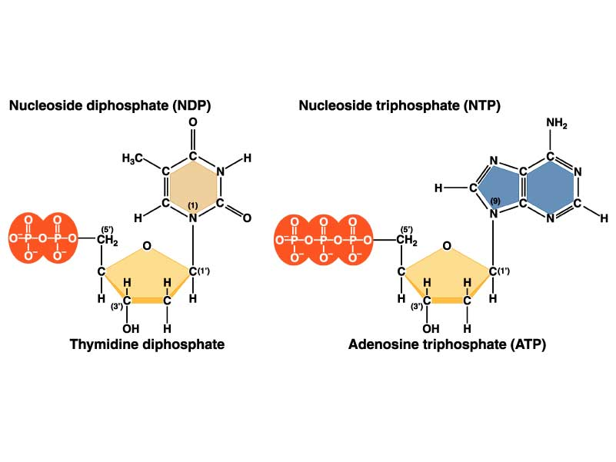

1. What is the name and location of the kind of bond that links a sugar to a phosphate group in the primary structure of nucleic acids (polymerization of nucleotides)?
2. What kinds of forces hold the double strands of a DNA double helix together? Do the two strands go in the same direction or in opposite directions?
3. Three types of RNA involved in comprising the structural and functional core for protein synthesis, serving as a template for translation, and transporting amino acid, Define each type
4. What is a codon? What is an anti-codon?
5. What codon(s) signal the start and stop of protein synthesis?
6. What are introns and exons?
7. Define transcription and translation. Which process occurs first in order to make protein from DNA?
8. In one sentence, explain what tRNA does.
9. What is the mRNA, and what is the amino acid sequence for the following DNA strand?

TACCAGGCTGTTACT

1. The following is a single strand of DNA: **3’** **TACACACAAACGGGG 5’**. Write the following in the space provided.

1. Complementary DNA strand:
2. mRNA:
3. amino acid sequence: